*Anomaly Detection meaning and Example:*  
Suppose you run an aircraft engine manufacturing factory. Now, consider that there is a batch of aircraft engines ready. Though before sending them to the assembly unit, you want to test whether they work properly or not. Now, we can have features x1,x2,…. xn  as heat generated by the engine , vibration intensity of the engine etc.

Suppose there is only x1 and x2 present. Now we have some already plotted some data points for x1 and x2 values as red crosses. The red crosses together represent a region of already tested engines, which means if a new data point falls in this region, then the probability of the engine being ok is significant, otherwise it is not.The x1 and x2 values of new points /new engine are recorded and plotted on the x1 vs x2 curve. If a point is in or near the middle of the red crosses, that engine is ok, if a point is too far from the red cross cluster, it means that the probability of that new engine being ok is really less.

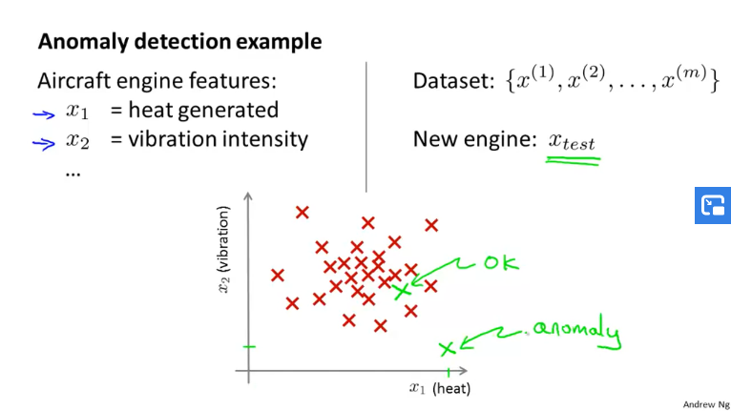

We selected a threshold probability value called epsilon and the new engines for whom probability of being in the region of the red cross cluster is greater than or equal to epsilon are classified as ok , while the other engines are classified as an anomaly. This is illustrated below:

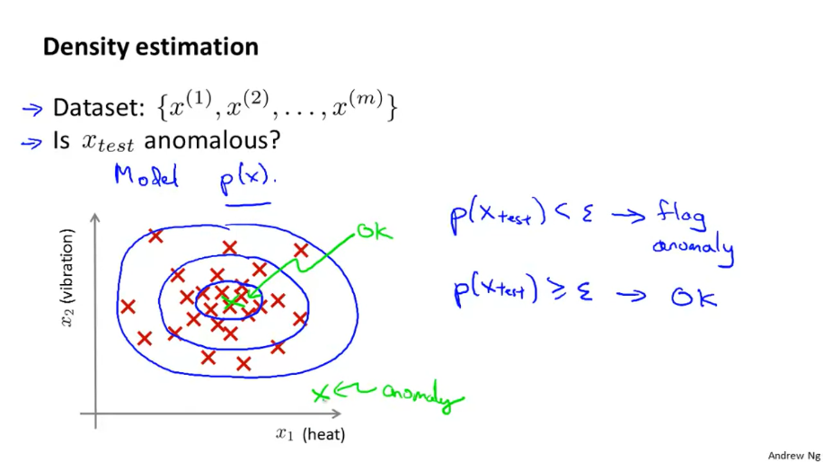

More examples of anomaly detection :

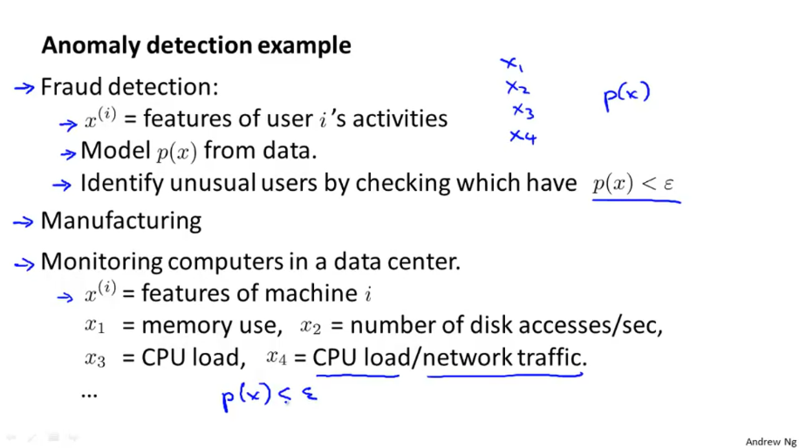

If we set some features of computers as x1, x2, …. xn and set a value of threshold probability as epsilon, we can track any unusual activity if a computer shows probability(x) <epsilon.

*Question:*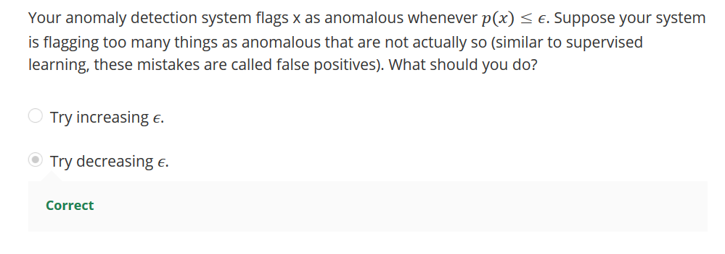

Explanation of the above is that, the epsilon value is incorrectly high because most of the p(x) values, even the ones that are well within being OK range are less than it. Hence, we need to decrease epsilon.

*Gaussian/Normal Distribution:*

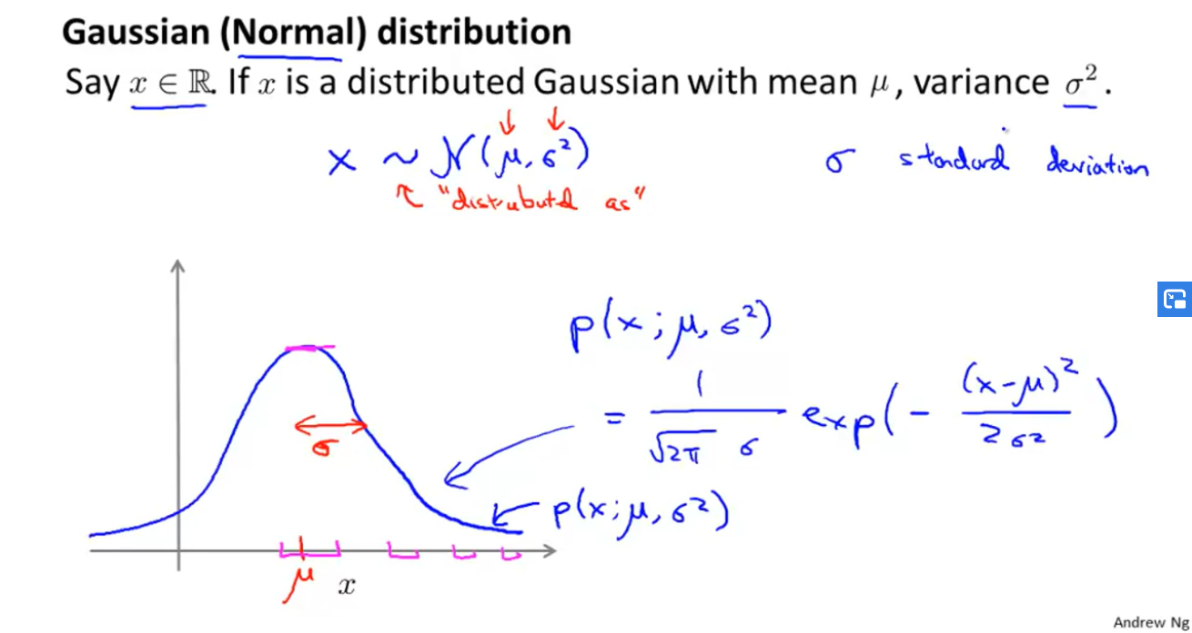

The spread of a normal curve is given by it’s standard deviation.

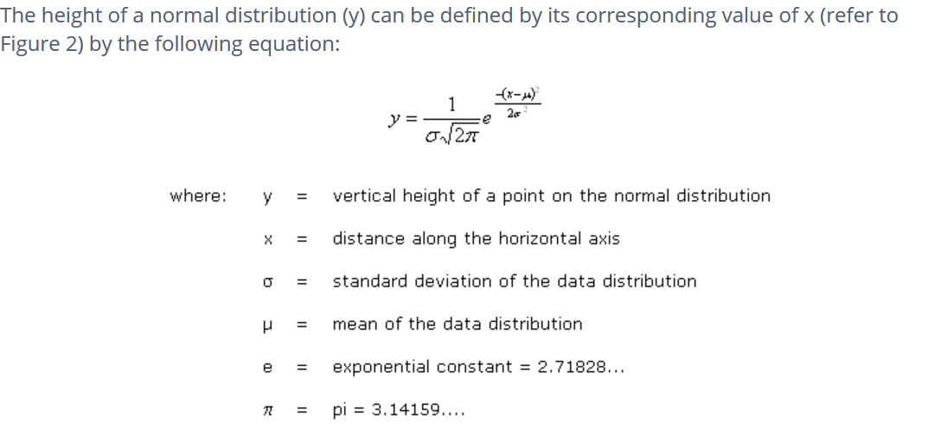

*How Mean and Standard Deviation influence the shape of a Normal Curve:*

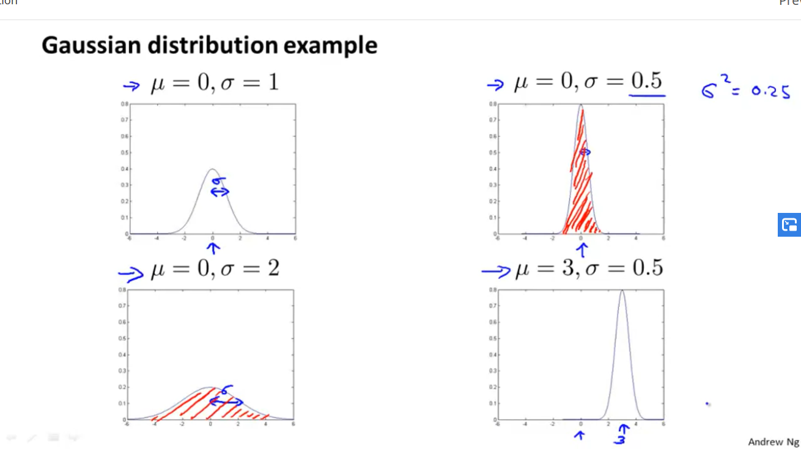

***MEAN AND STANDARD DEVIATION:***

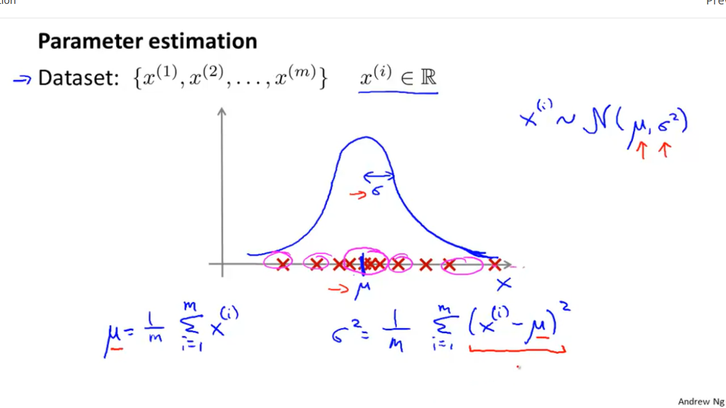

*ANOMALY DETECTION ALGORITHM:*

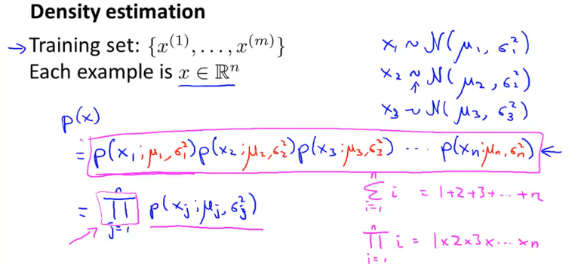

Note: 1. x1 means data entered in 1st column of all the rows i.e. x11 , x12 etc.

2. u1 is the mean of all the data present in column 1, u2 is the mean of all the data present in column 2 etc.

3.

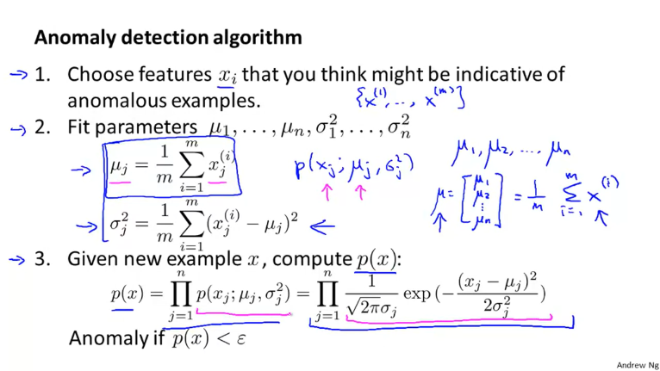

*Example:*

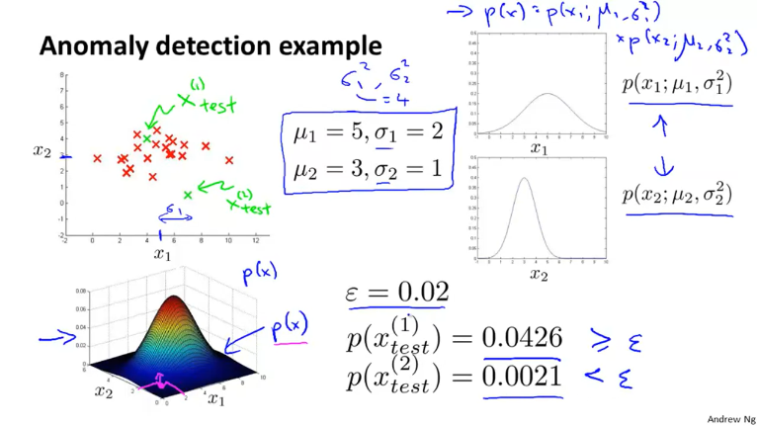

Note the graph on the lower left corner gives probability value for corresponding x1 and x2 values. If a point is in the middle of the plane represent by x1 vs x2 , then it’s probability value is very high, whereas if a point is to the top left corner like point a , then it’s probability is very less.

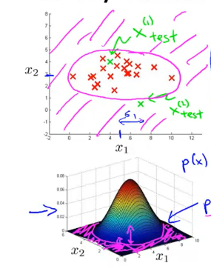

The area in pink represents points whose probability is very low.

*Question:*

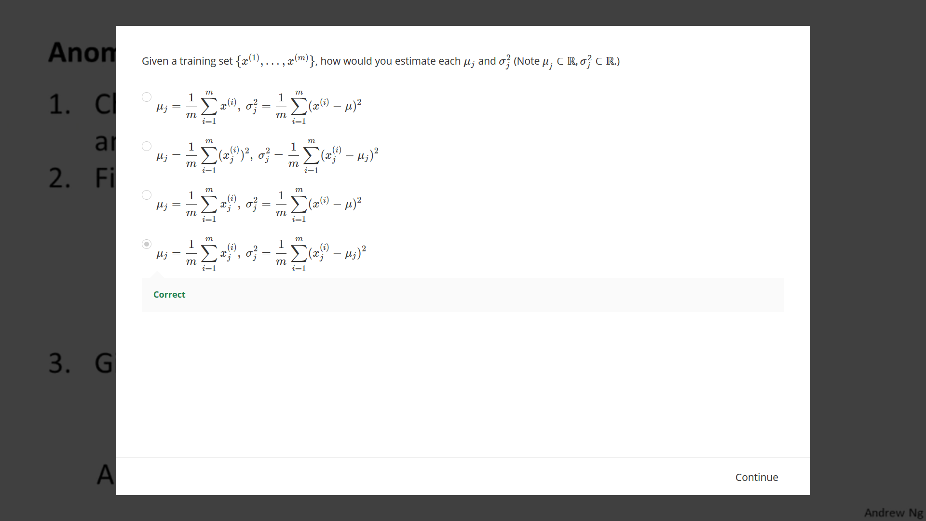

*How to Develop and Evaluate an Anomaly Detection System?*

Note: We have an already labelled set of data (labelled as anomaly or normal) and now we are trying to predict the labels/values of y (0 or 1) for some new values of x.

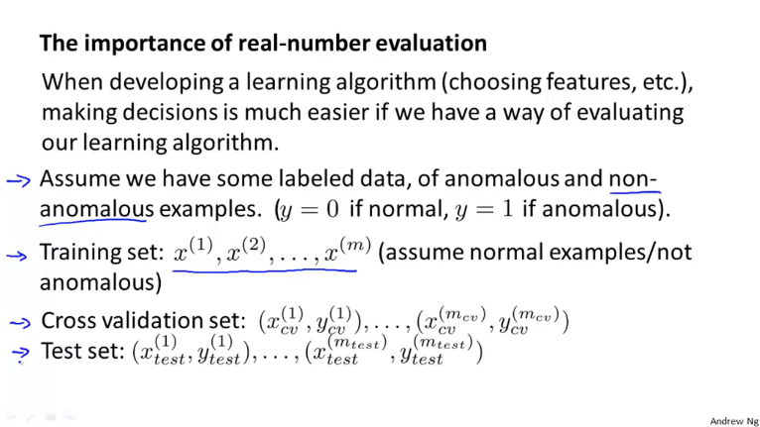

We evaluate our features using the cross-validation set. Then we finally test our model using the test set.

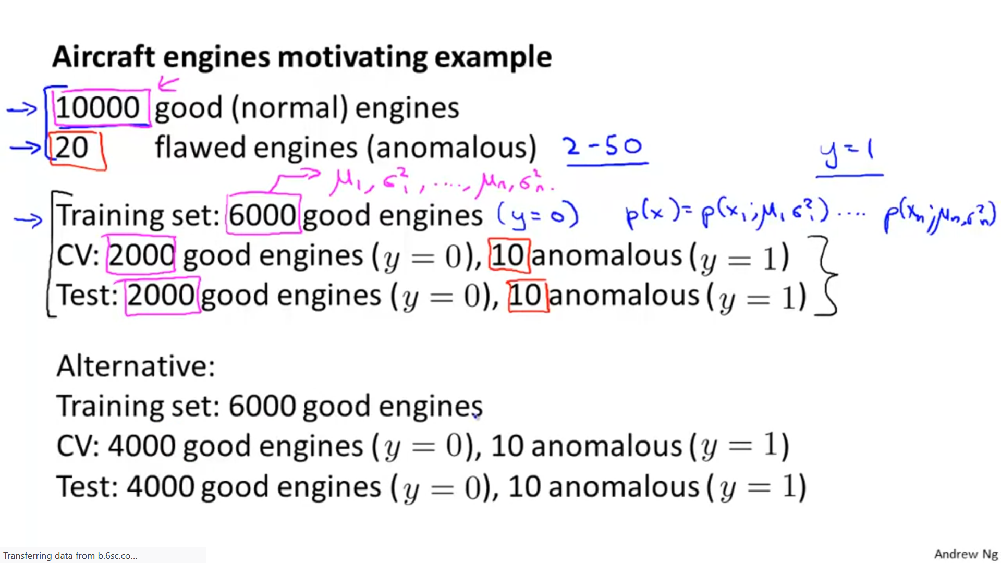

The alternative method is usually not preferred, since we prefer having different cross-validation and test sets. Now, usually we have unlabelled data, but here we have assumed that most of the values of p(x) correspond to a normal engine and only a small proportion of them correspond to an anomaly.

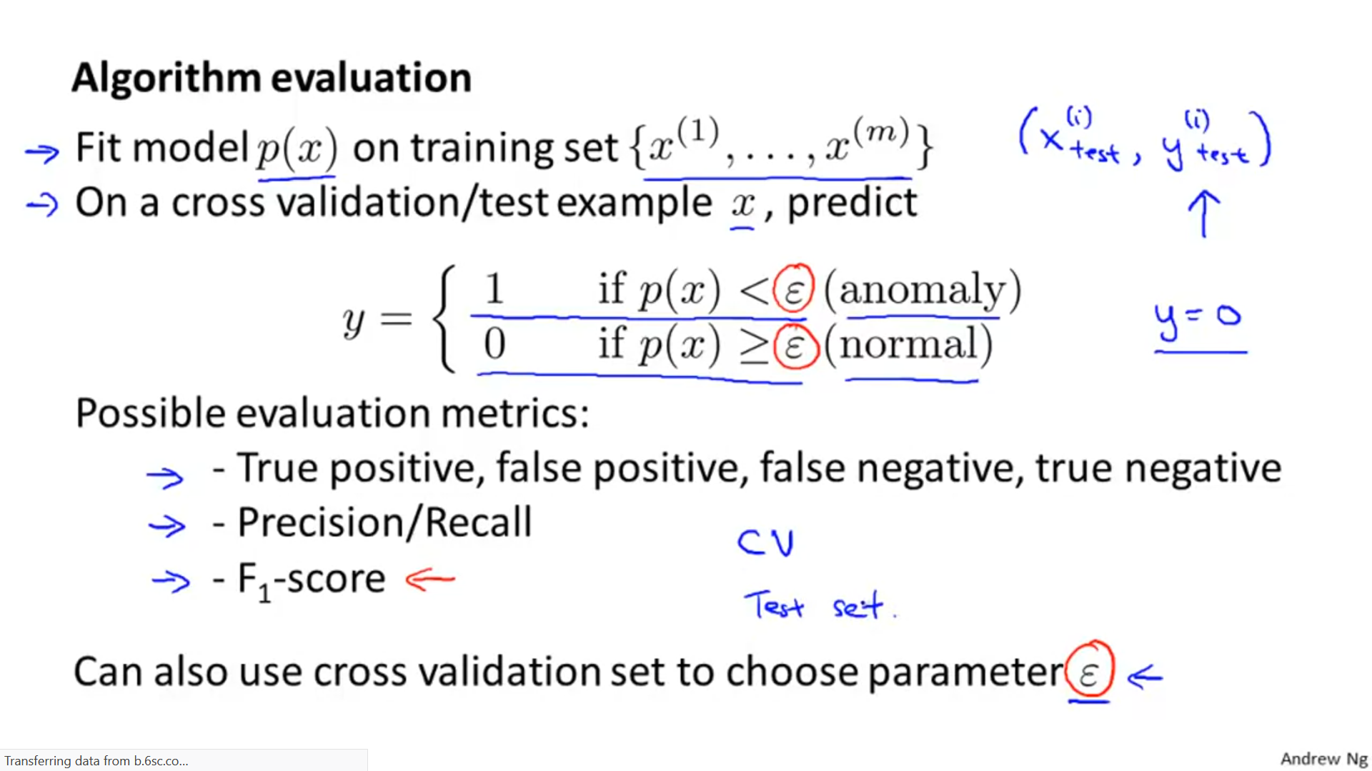

We evaluate our model for different values of epsilon and different features of X using the cross-validation set. We can also check the precision/recall value using F1 score metric for different features/epsilon values.

Note: We do not prefer to use classification accuracy as a method of evaluating the perform of our model, since we are assuming that are model has data X that is skewed i.e. most of the values of p(x) correspond to a normal engine and only a small proportion of them correspond to an anomaly.

*Question*

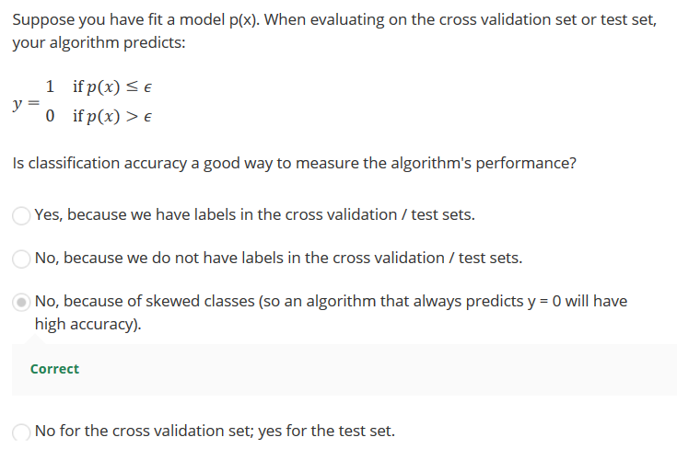

*Anomaly Detection VS Supervised Learning:*

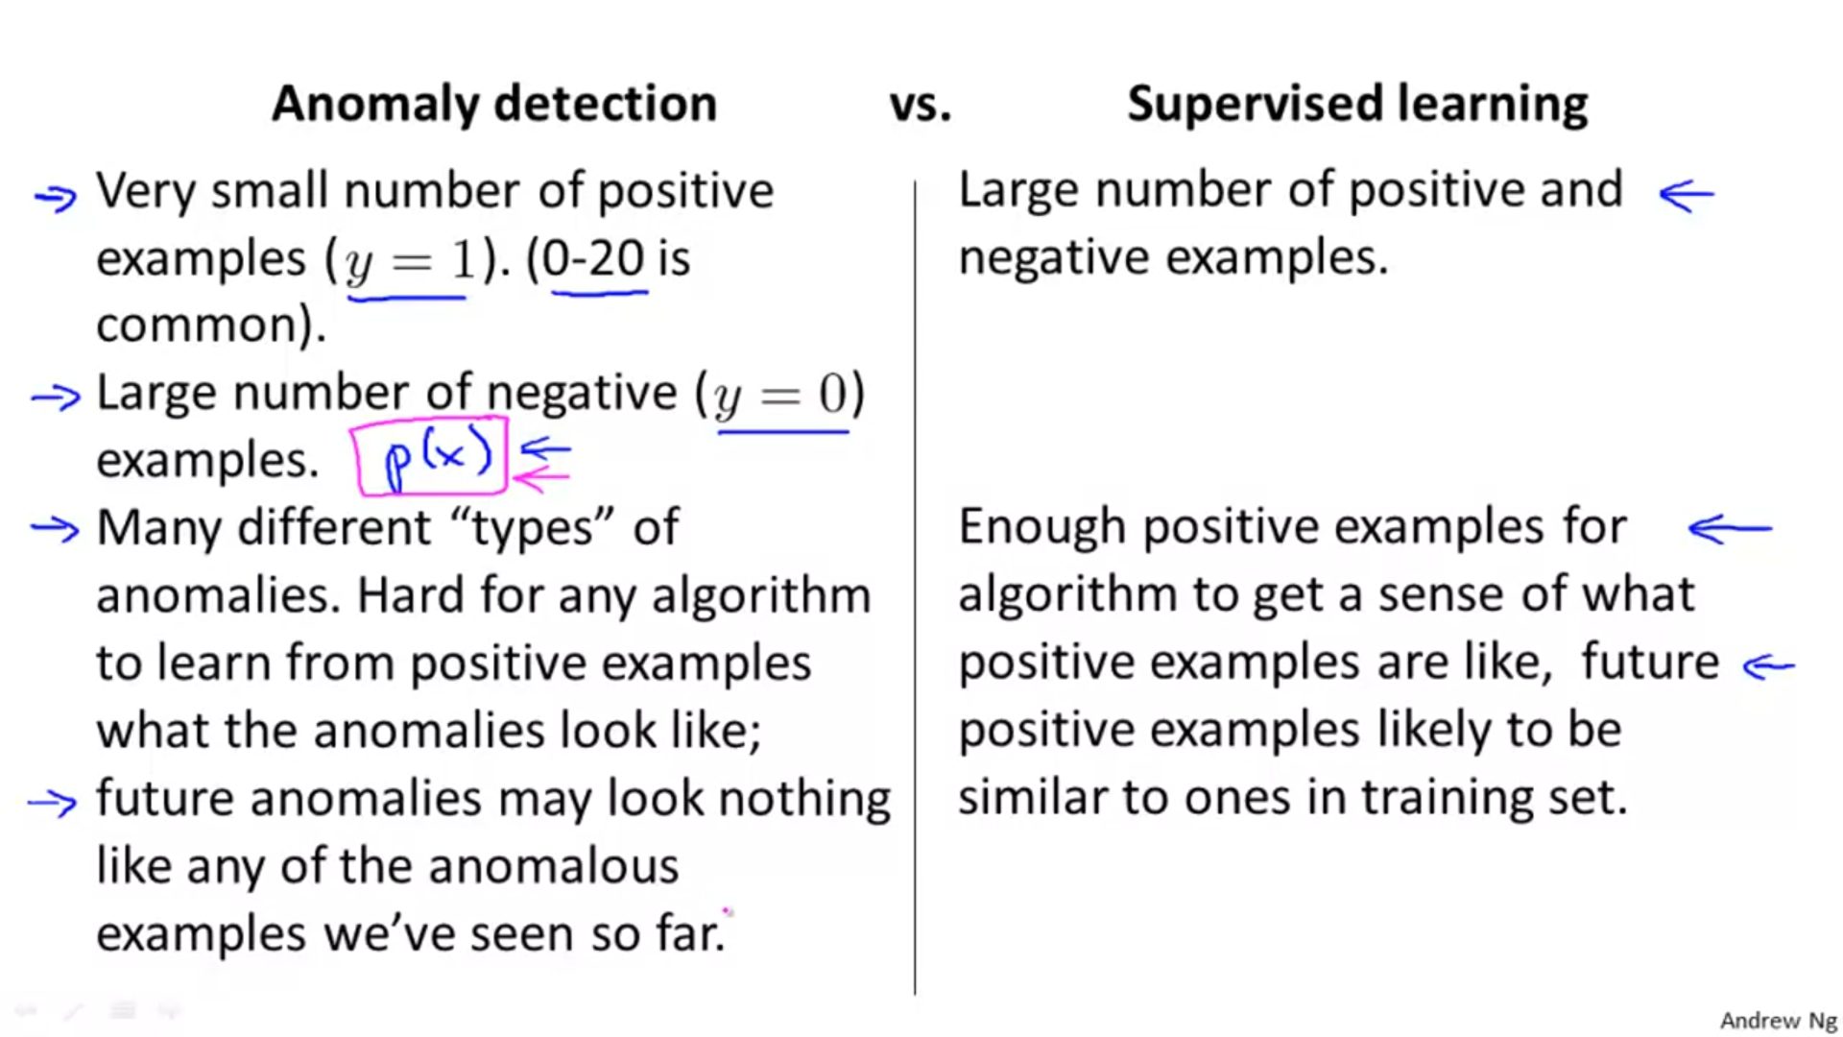

When we have a dataset in which there are very few positive examples, we train our model using the negative examples and reserve the positive examples for the cross validation and test sets. In such a case, we use anomaly detection algorithm.

Note: Here positive examples mean that there is an anomaly/problem and negative examples mean that there is no such problem i.e. the examples are normal.

Also note that many different types of anomalies means that there may be certain parameters that we have not identified, but can contribute to a faulty engine. Now since we are training our algorithm on the normal/negative examples , we have defined a certain value of epsilon below which we classify an example as an anomaly using our normal examples. So , we need not worry about further unidentified parameters that can cause an anomaly because our model is not dependent on the parameters that contribute to a faulty engine but rather the parameters that contribute to a non-faulty engine.

*More examples:*

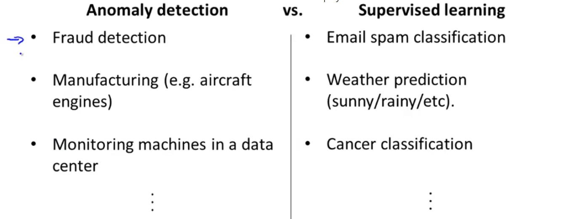

*Question:*

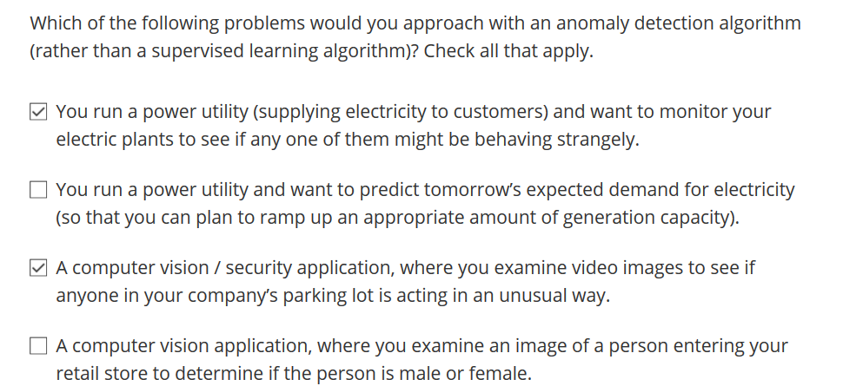

*CHOOSING WHAT FEATURES TO USE:*

1. Dealing with non-gaussian features: The anomaly detection algorithm works fine with both non-gaussian as well as gaussian features. Although, it works a bit better with gaussian features.

We can convert non-gaussian features to gaussian by taking certain transformations such as log transformation, square root, cube root etc.

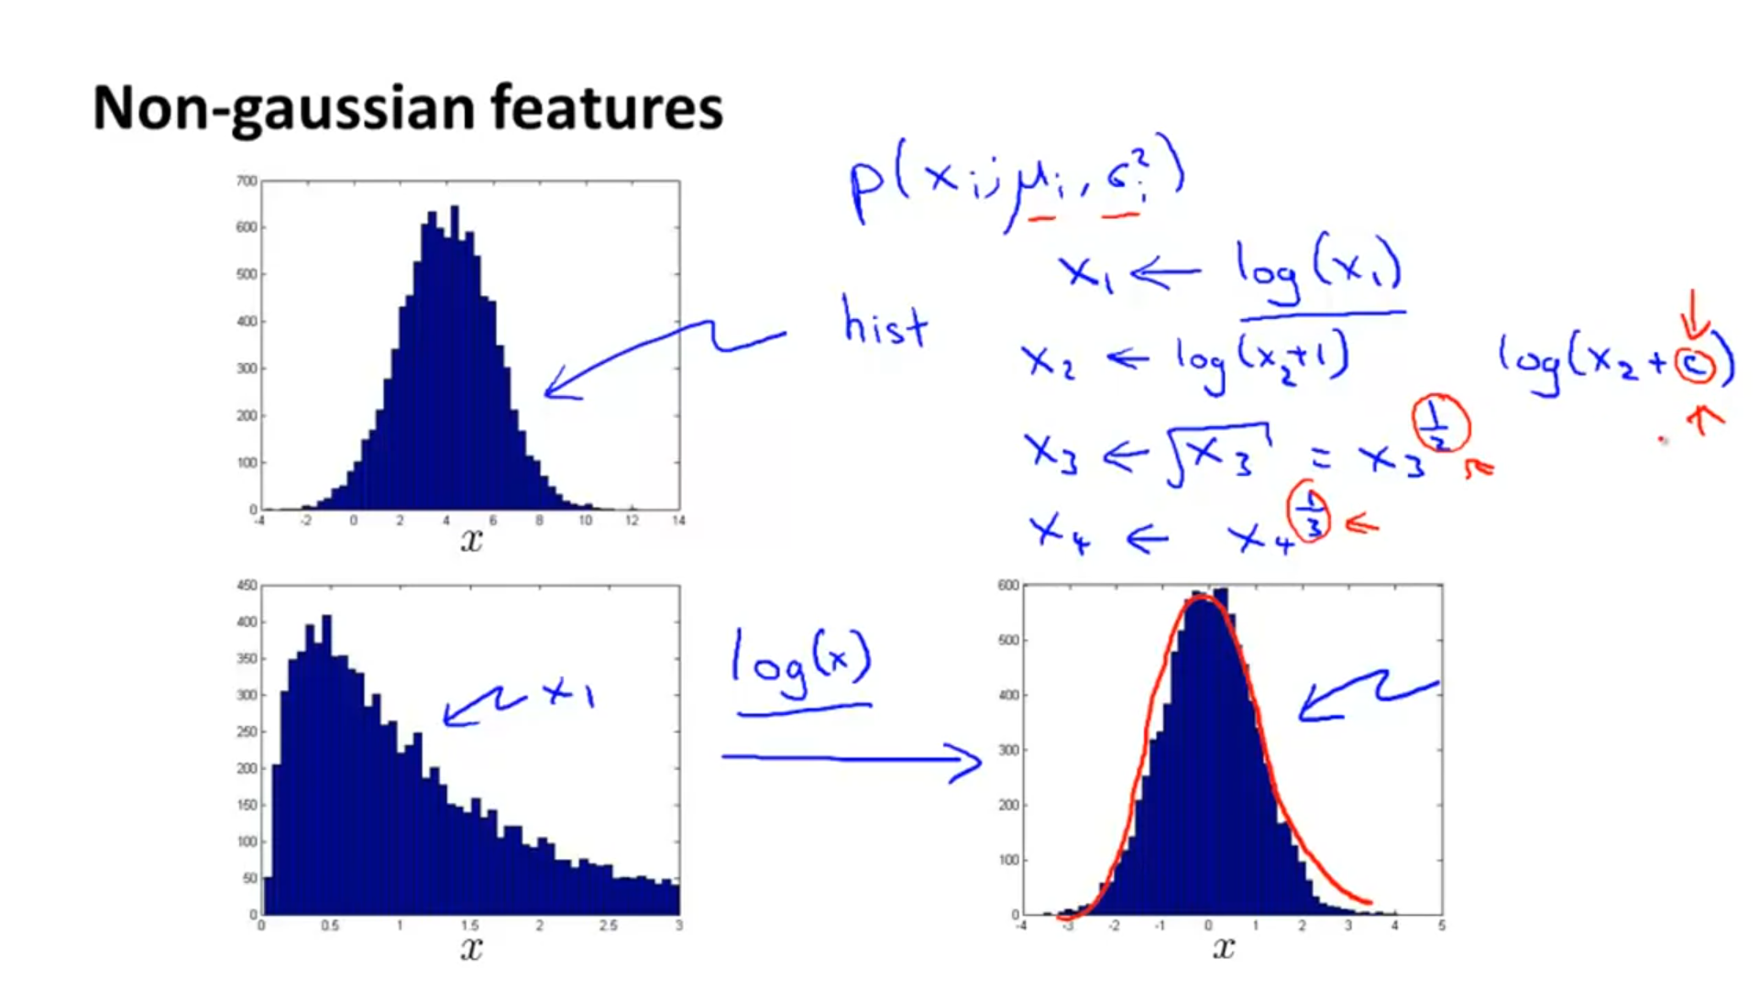

*Error Analysis:*

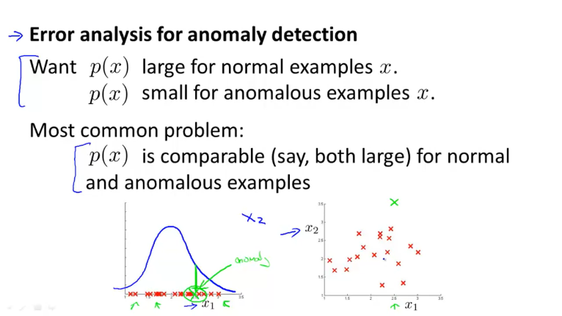

Suppose our algorithm wrongly classified a data point x (shown in green). Now, we have to introduce a new feature say x2 which classifies this example as an anomaly. So though x1 is still=2.5, the data point x is classified as an anomaly due to the new feature x2 .

*Example:*

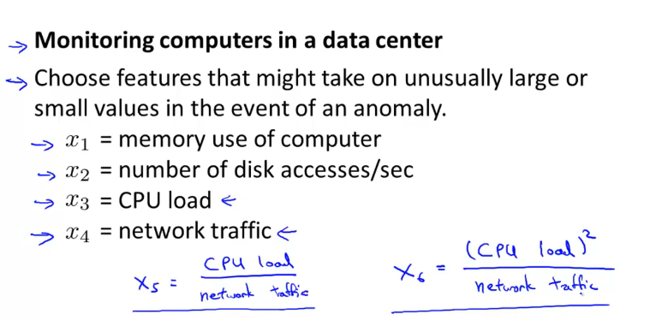

Let us consider that we face a common problem at our data center that our CPU load increases a lot maybe due to some infinite loop or some other error. Yet when the CPU load increases, the other features like network traffic remain almost constant and thus a computer with high CPU load alone cannot be classified as an anomaly. So, in order to classify or highlight such a computer as an anomaly, we introduce new features like x5 or x6 which can help in correct anomaly detection.

*Question:*

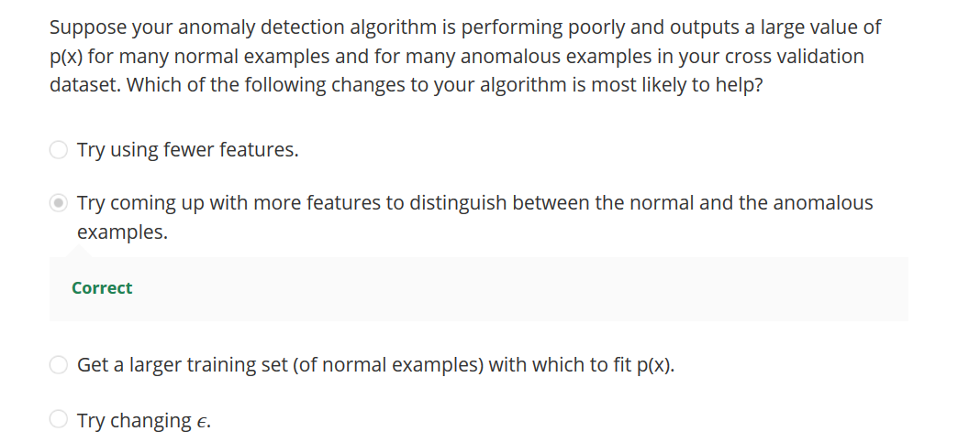

*Different types of Gaussian Distributions depending on values of mu and sigma:*

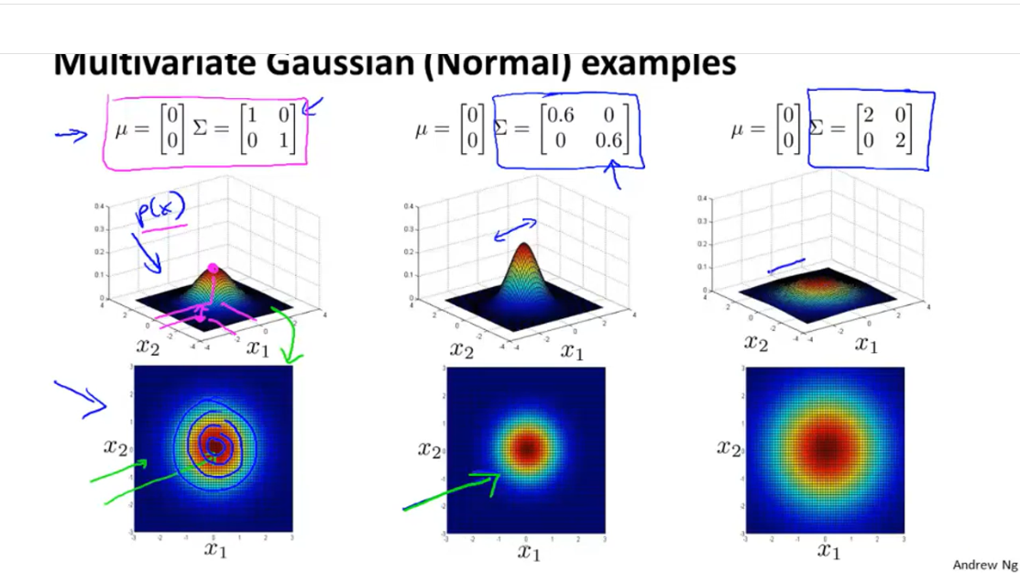

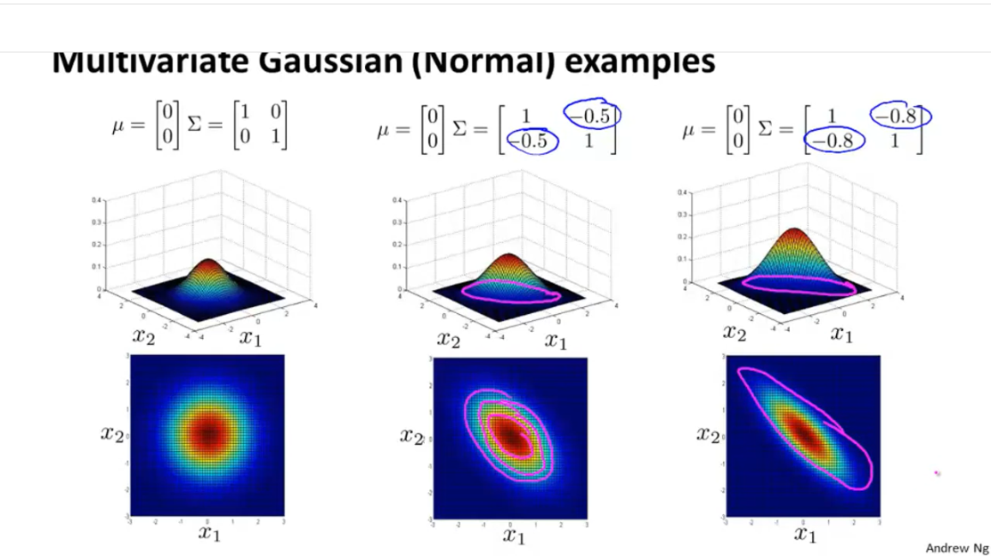

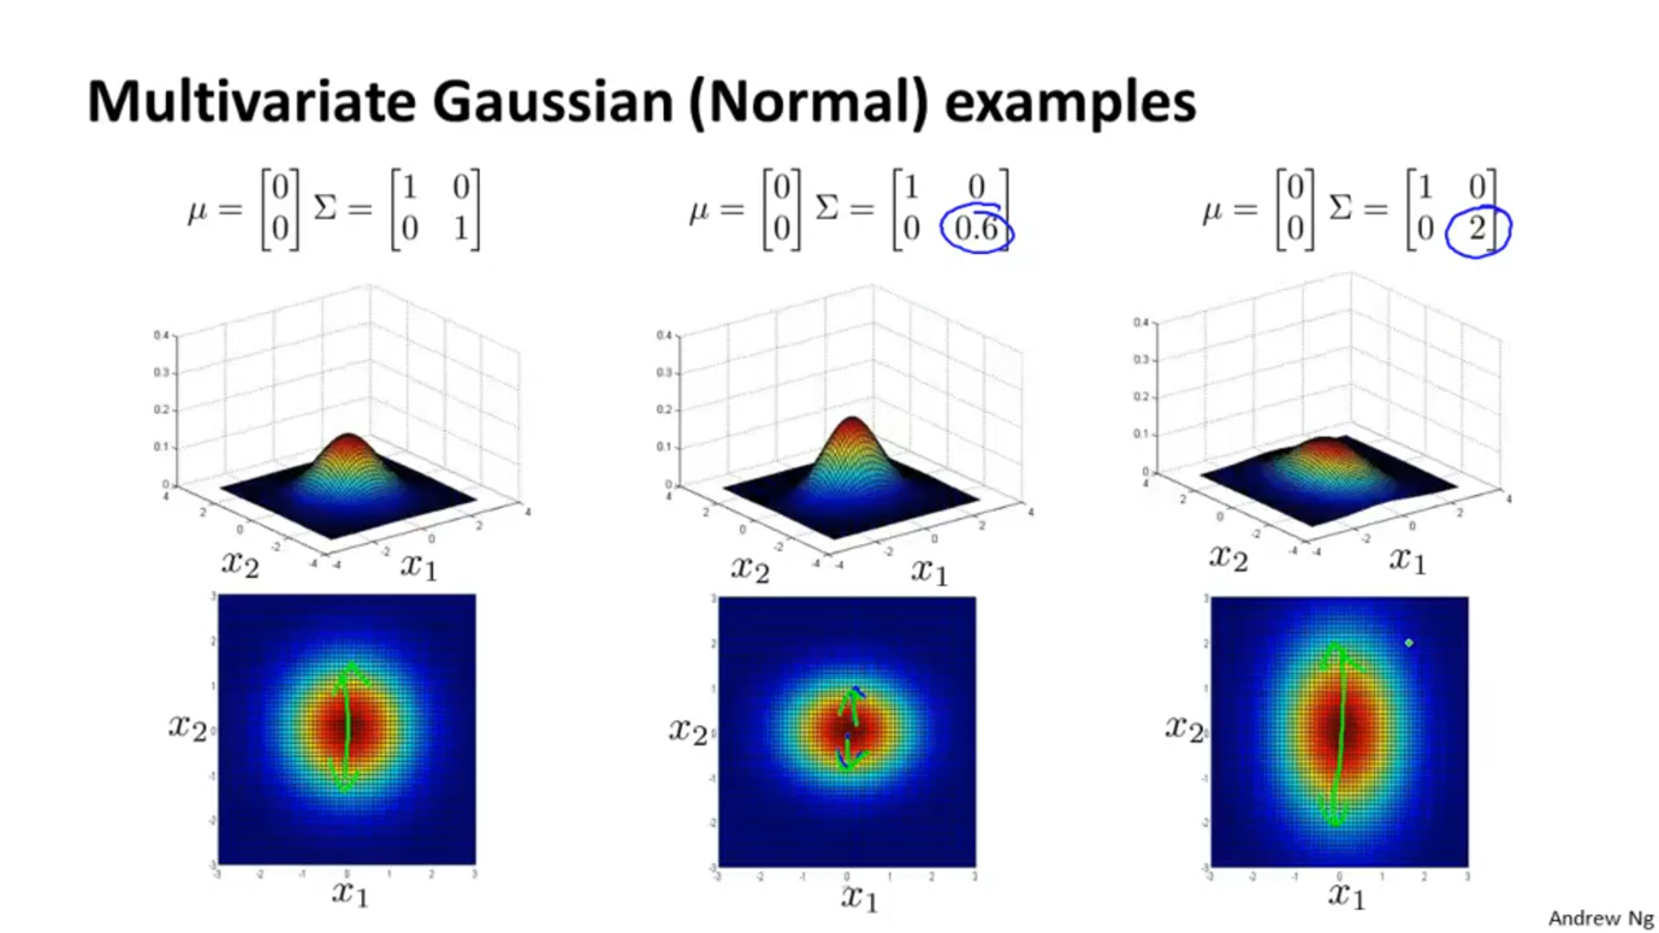

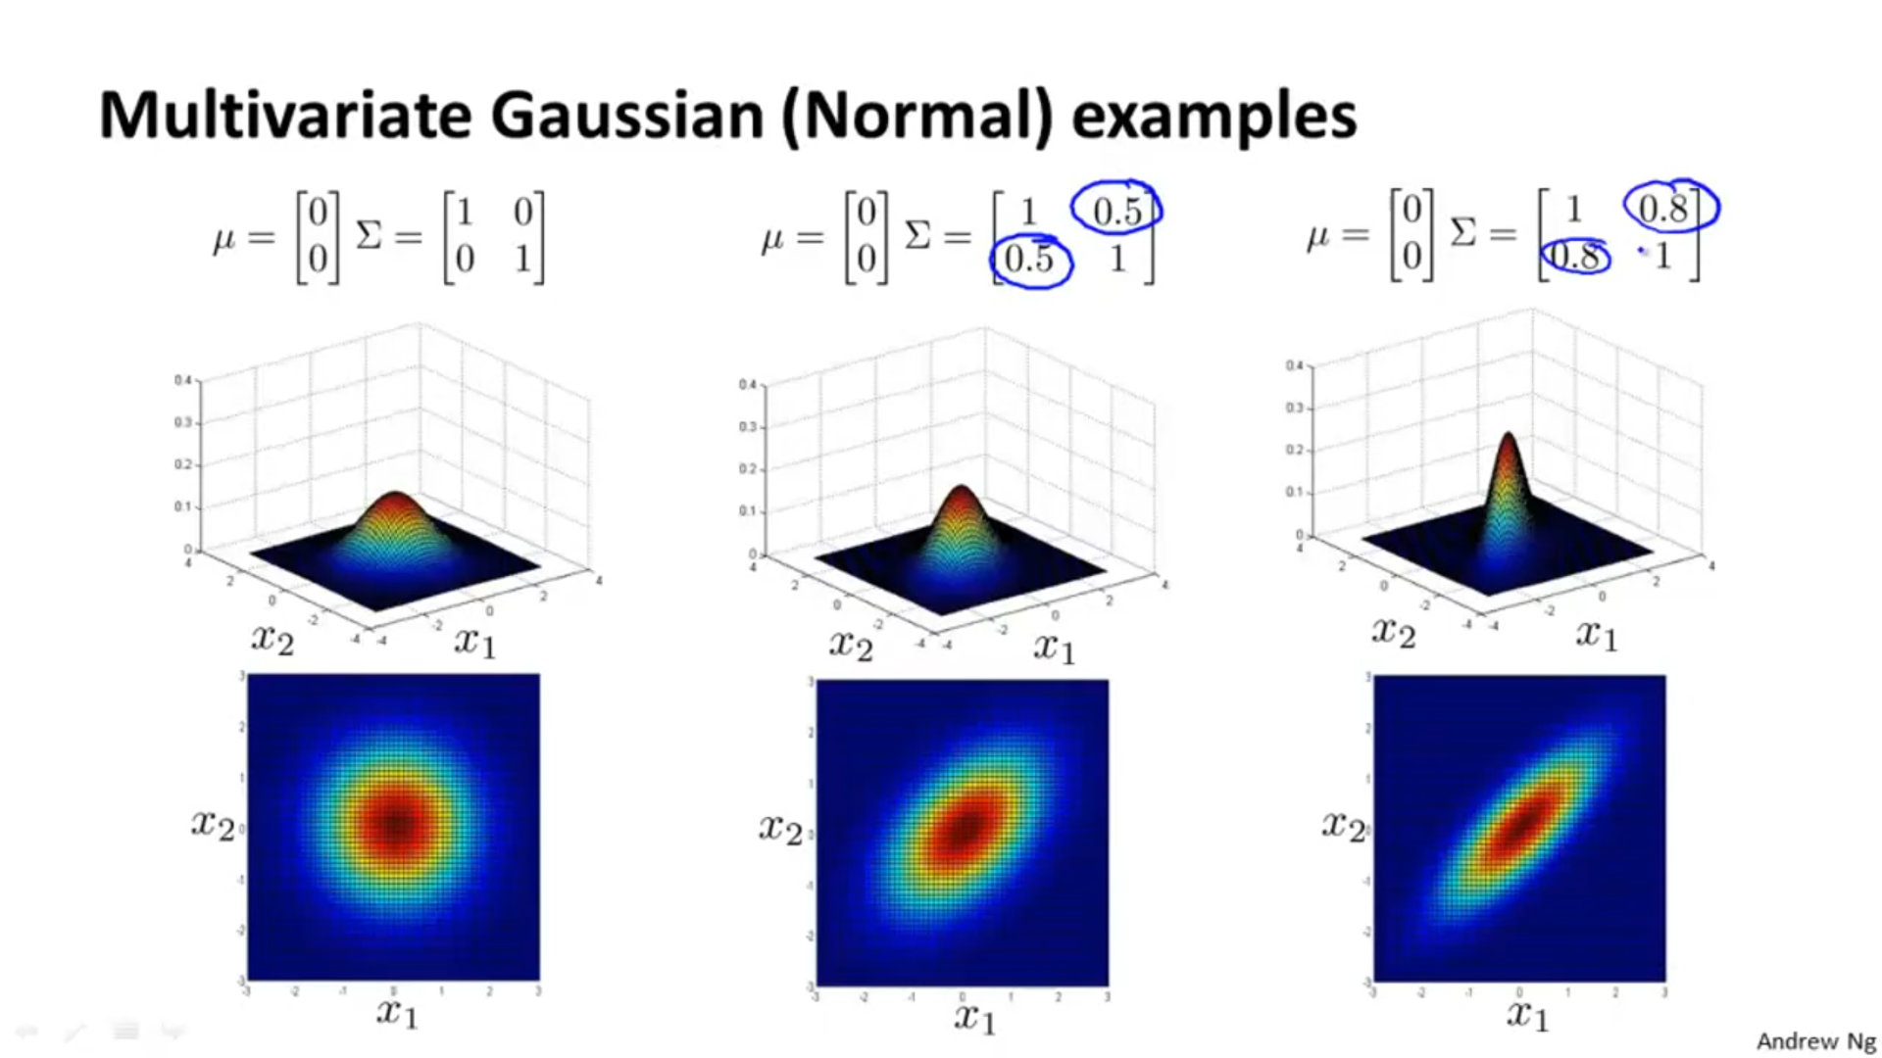

Above distribution can be used to check the correlation between x1 and x2 .

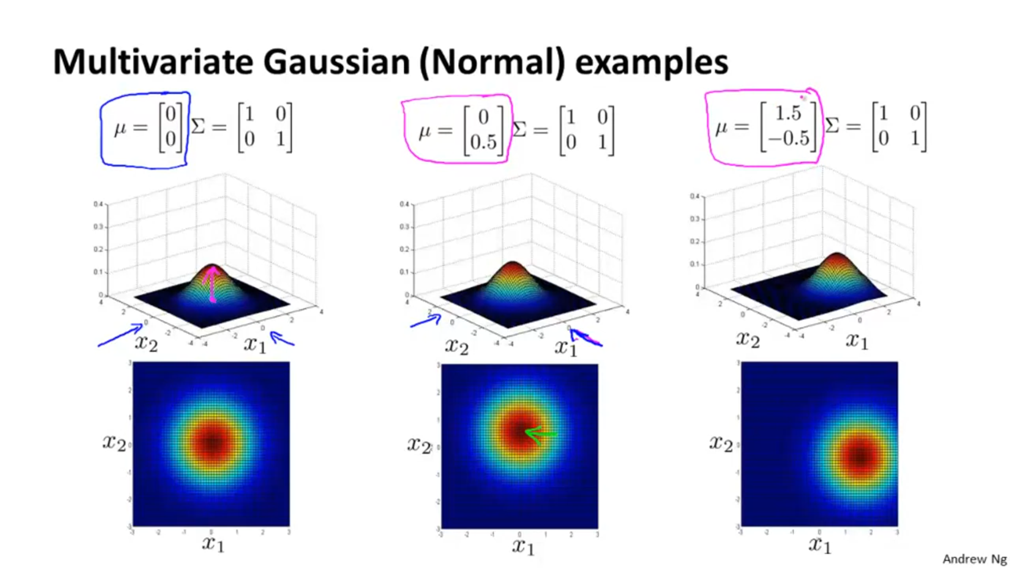

*Question:*

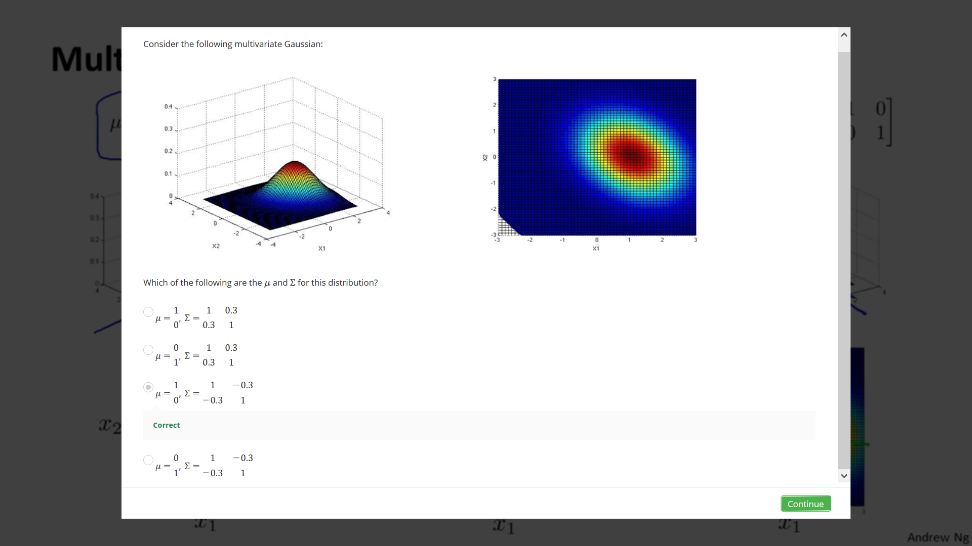

*Detecting Anomalies using Multivariate Gaussian Model:*

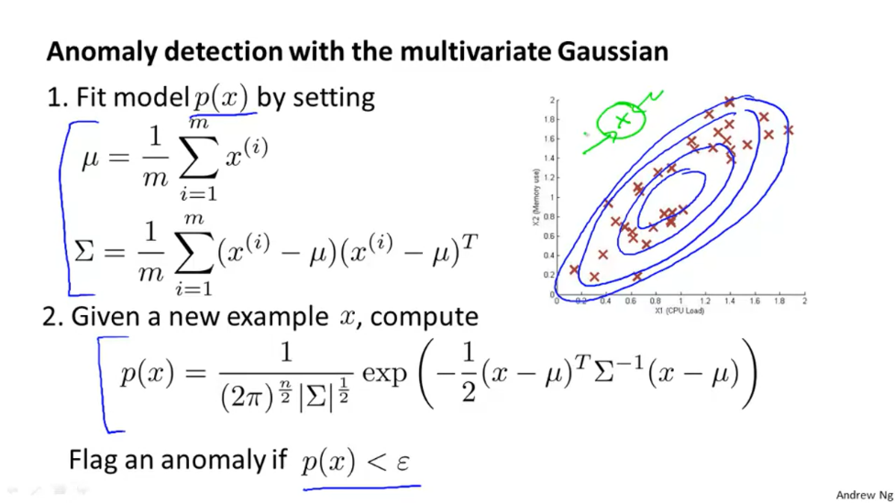



The region in sea green is the area of highest probability, as we move away from this area, the probability keeps on decreasing. Point X is really far from this area and thus has a really low probability and hence is labelled as an anomaly.

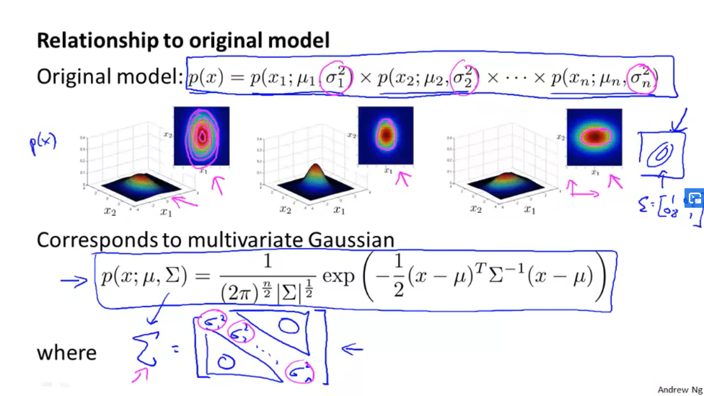

Note: The above original model is a special case of the multivariate gaussian model, in which the diagonals of sigma are equal to 0 or sigma varies linear along the axis. The graph in blue on the top right corner of the screen shows a graph in which value of diagonals of sigma is not 0, it is 0.8 .

*Difference between the Original Model and Multivariate Gaussian Model:*

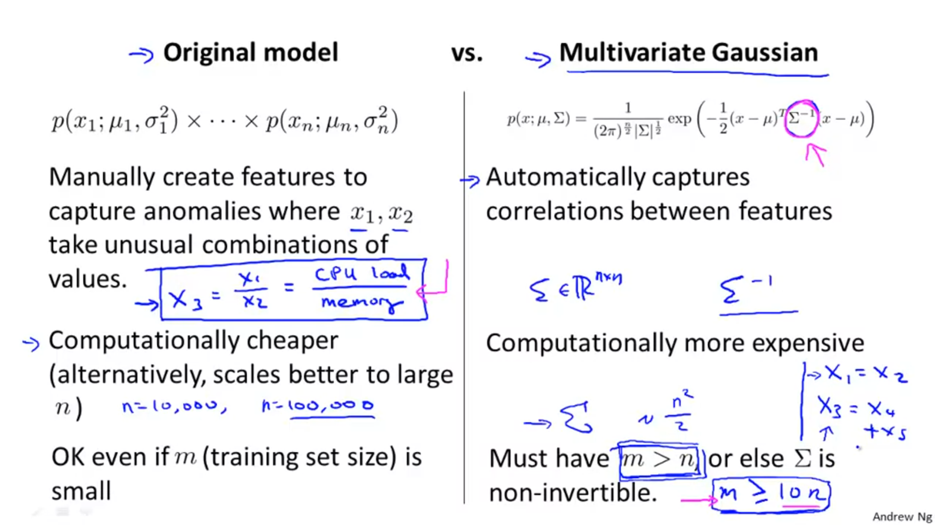

*Note:*

1. Multivariate gaussian model is computationally expensive because, in it we have to compute sigma-1 and if sigma is very large like 100,000, then computing the inverse of a 100,000 by 100,000 matrix is really difficult.

2. If x1, x2 …xn­ are correlated then multivariate gaussian model won’t be able to invert sigma and hence won’t be able to calculate its inverse. Eg: As given above if x1 = x2 or x3= x4 + x5 then features x2, x4 and x5 are redundant or useless.

3. For sigma to be invertible m should be a lot greater than n. Say m>= 10n.

*Questions:*

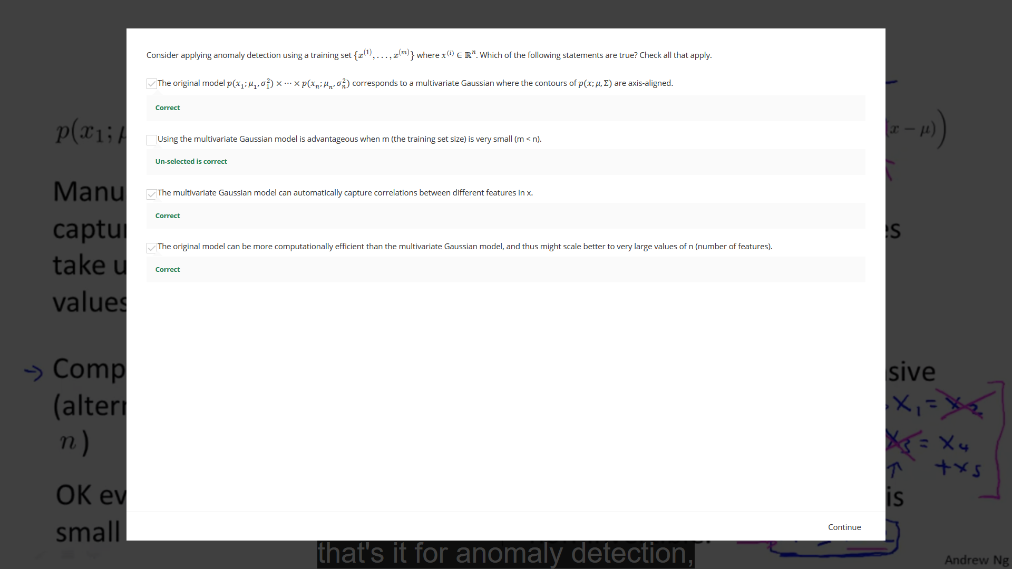

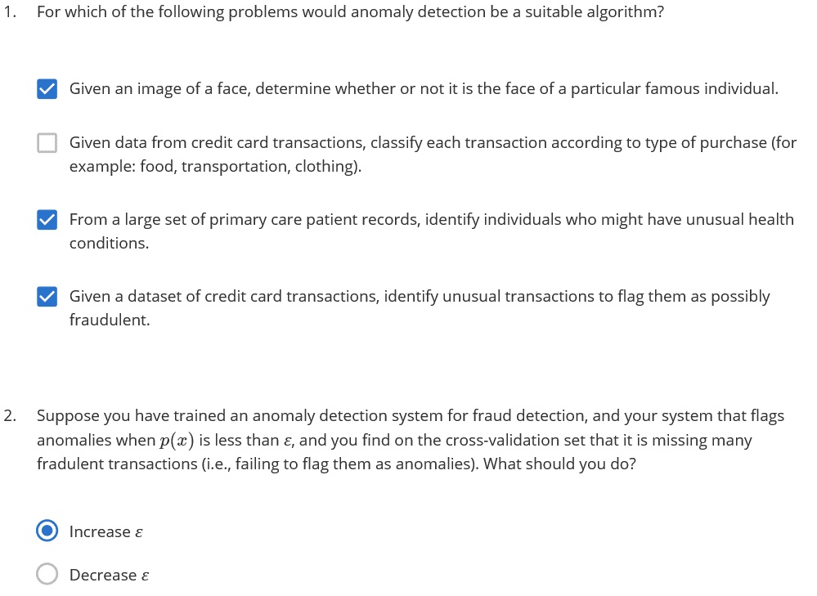

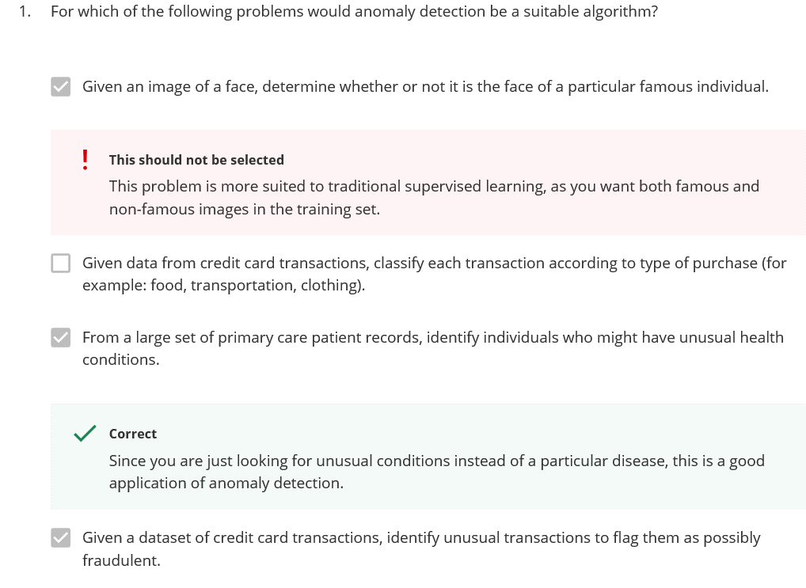

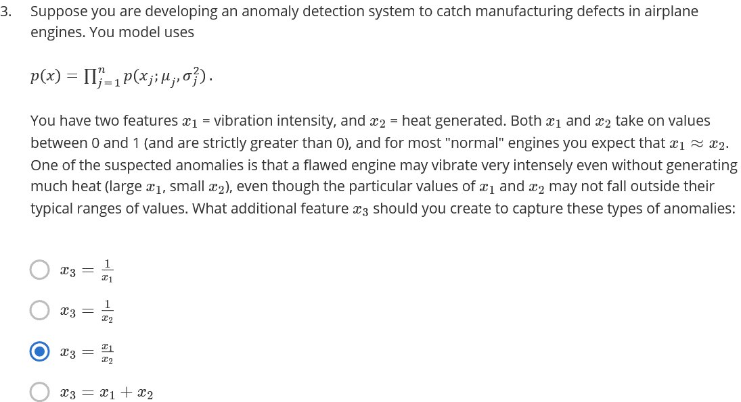

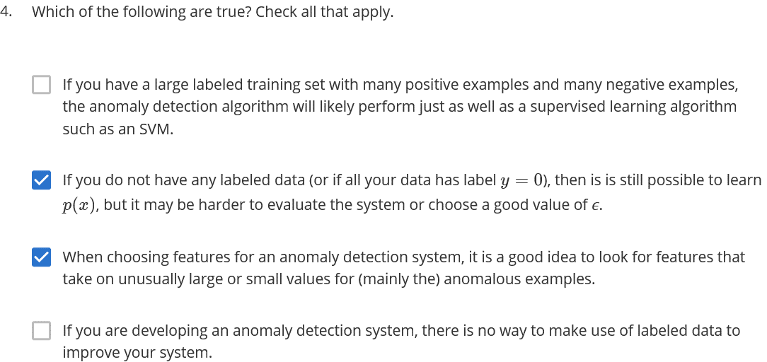

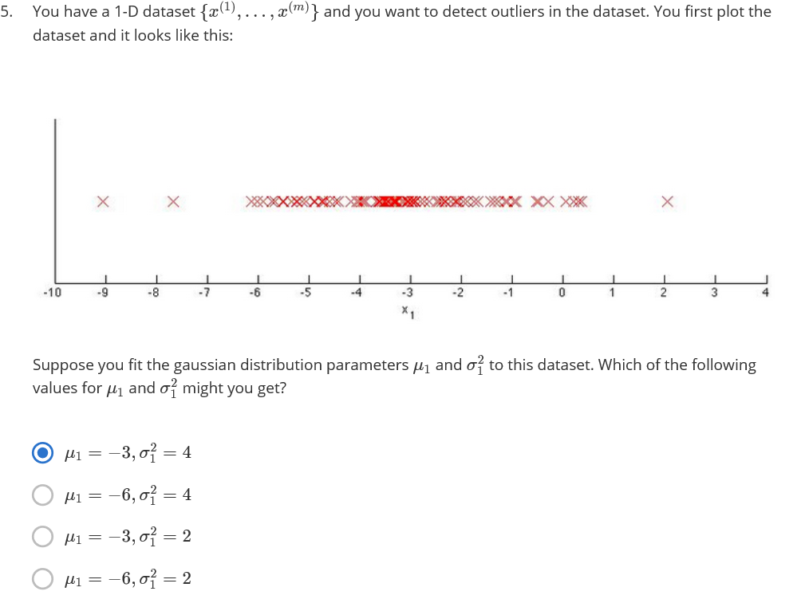

*Content Based Recommendations:*

Consider the following figure:

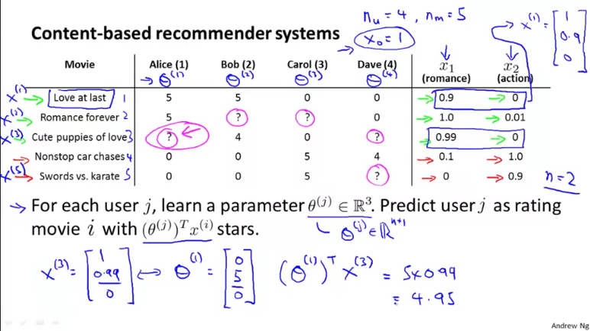

Here we are trying to predict whether a person say Alice would like a movie like Cute puppies of love, for which they have not voted.

As parameters x, we have certain features x1 and x2. The y values for Alice are the values below the column Alice i.e. 5, 5, 0, 0 .

We try to determine the value of theta for which the cost function is the minimum.

*The Cost Function:*

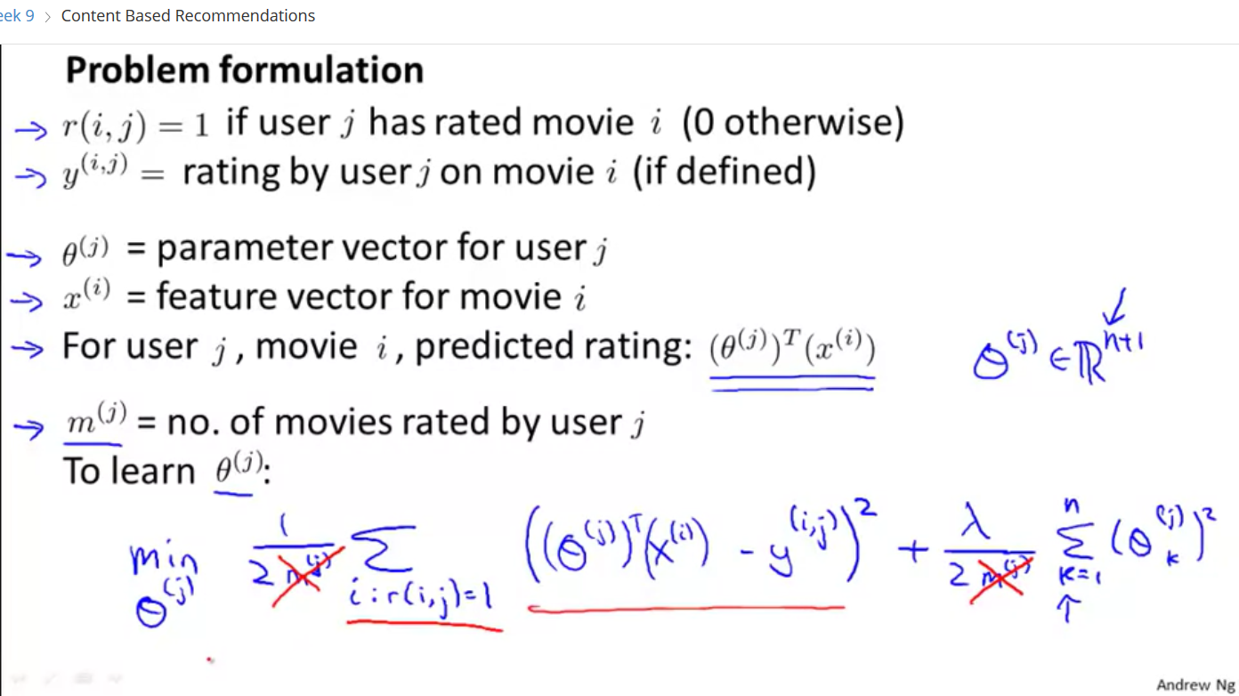

We remove m from the regularized cost function of linear regression to get the above given cost function.

i : r ( i , j )=1 means that we take only those values of movies i for which user j has given a rating.

Each movie has it’s own feature vector xi which when multiplied by theta values corresponding to each person gives the person’s predicted opinion about the movie.

*Example:*

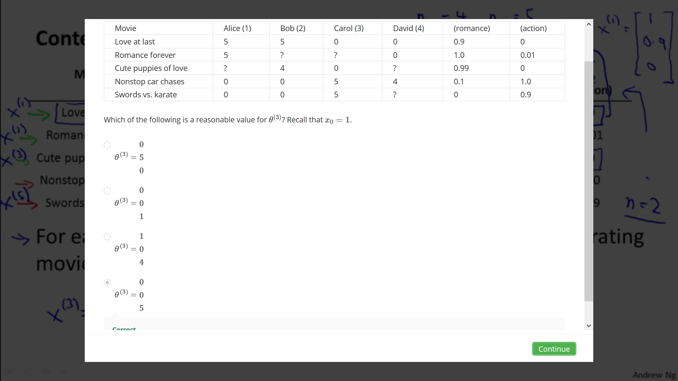



Now, for each movie, we have feature vector x0, x1, x2. Theta1 corresponds to Alice, Theta2 corresponds to Bob and so on.

When we multiply Theta3 with x values for romance forever , we get the predicted rating given by Carol for this movie. When we multiply Theta3 with x values for Nonstop car chases, we get the predicted rating given by Carol for this movie.

In the Question above, the best value of theta3 is option d) because when we multiply these values of theta3 with corresponding x values for each movie , we get predicted movie rating of each movie for Carol:

Love at last= 1*0 + 0.9*0 + 0*5=0

Romance forever= 0*1 + 1*0 + 0.01*5=0.05

.

.

.

Swords vs Karate= 1*0 + 0*0 + 0.9*5=4.95

*Optimizing values of Theta:*

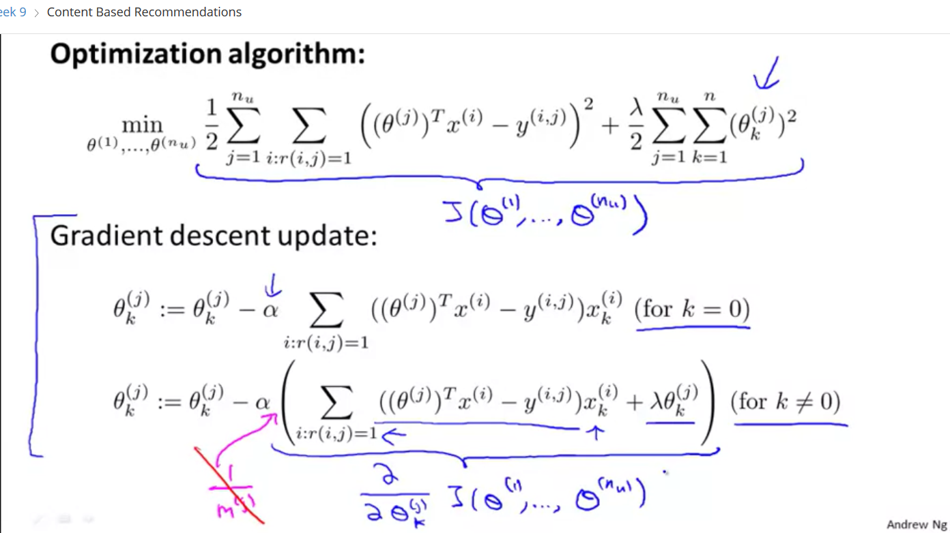

*Collaborative Filtering:*

In the above slides, we tried to predict the best values of Theta, given parameters x. Now, we will see a reverse method, i.e. given Theta values we will try to predict the best values of parameter x that will minimize the cost function.

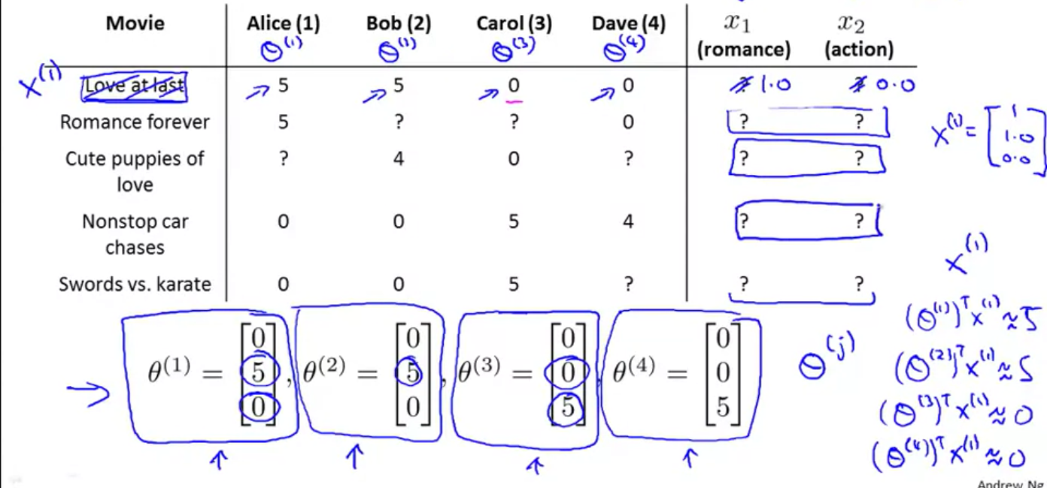

The lower right corner of the above image shows that for the movie Love at Last, we are trying to best values of parameters x , which when multiplied by the theta values for each of the 4 persons , predicts their review about it and also minimizes the cost function.

*Example:*

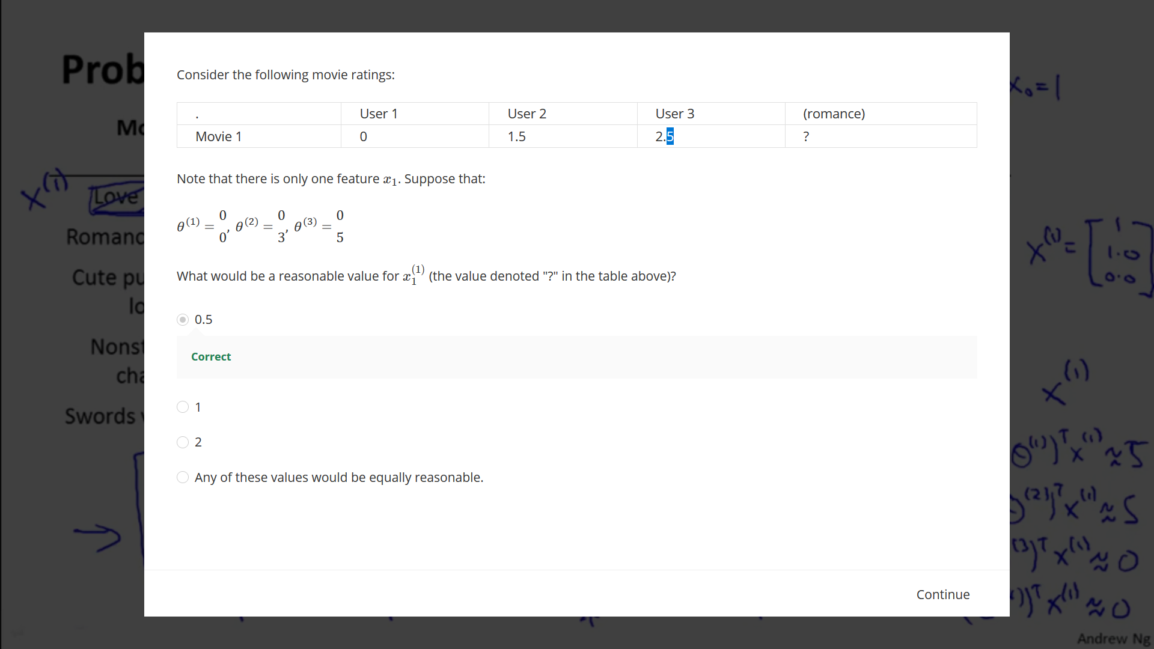

We know the values of theta1, theta2, theta3. Now we want to find the best values of x so that when thetaT and x are multiplied , we obtain the most accurate values of y.

We find that the best value of x is [1 0.5] ,because when x is multiplied by thetaT, we obtain:

For user 1: 0*1 + 0*0.5=0

For user 2: 0*1 + 3*0.5=1.5

For user 3: 0*1 + 5*0.5=2.5

*Cost Function:* 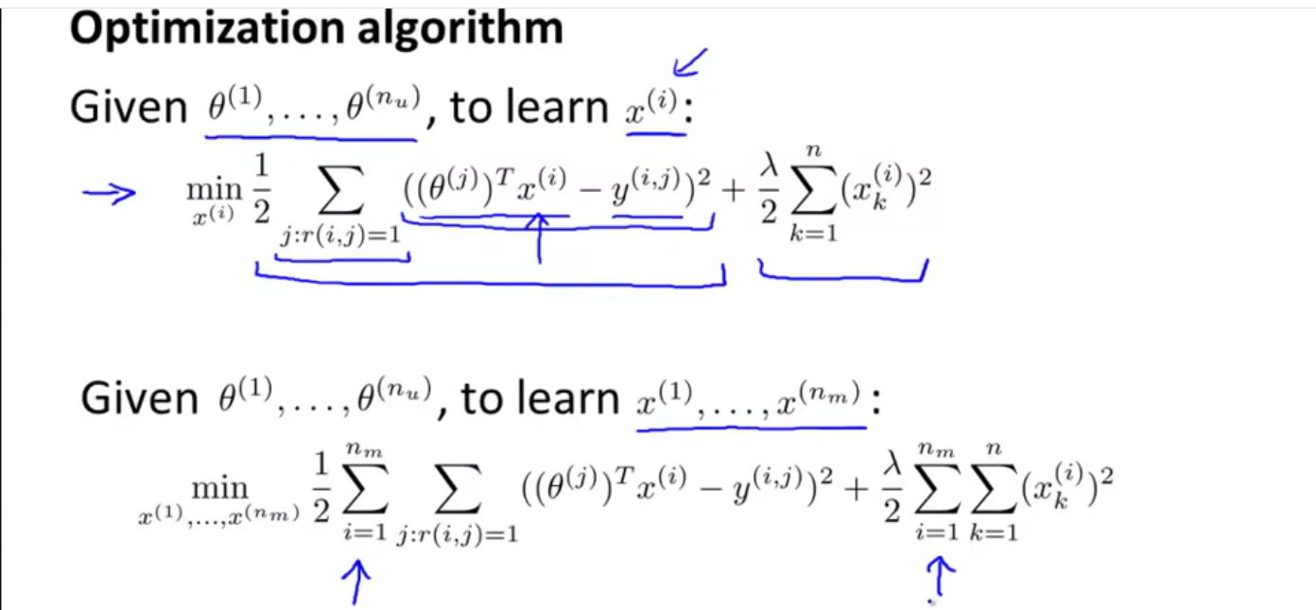

*Gradient Descent:*

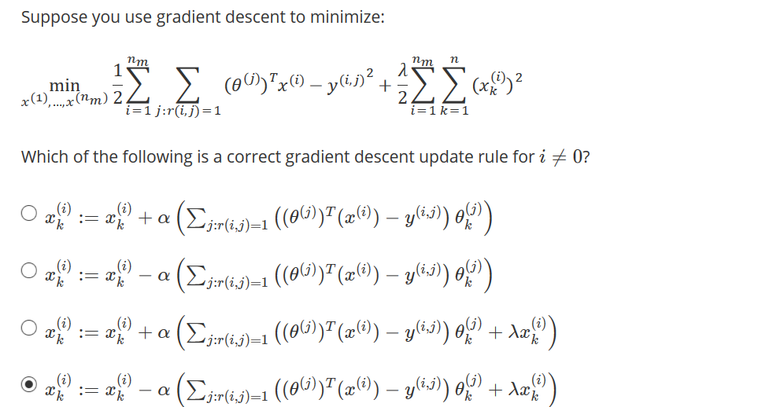

*Conclusion for Collaborative Filtering:*

Check out the image below:

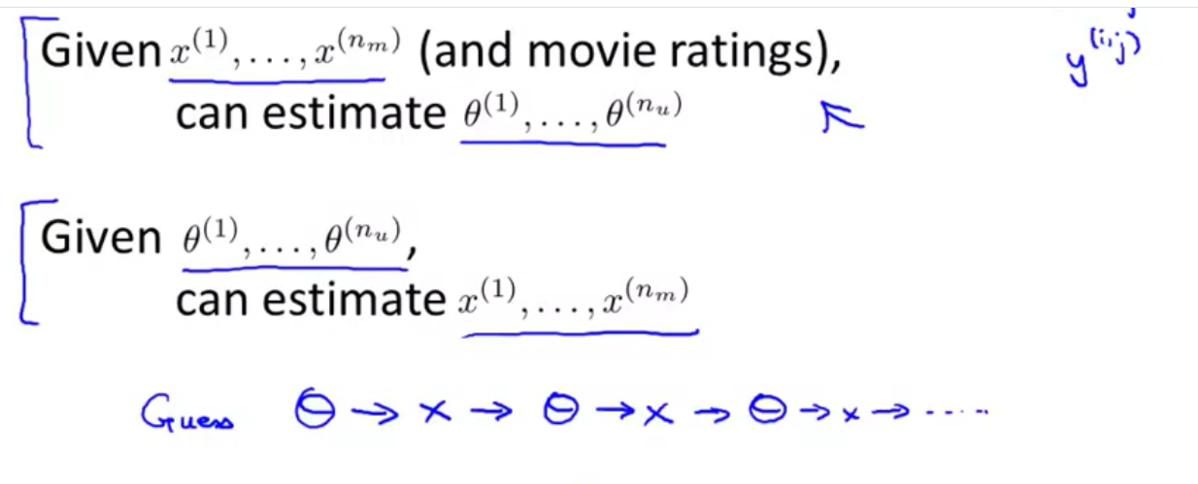

*Practicing Collaborative filtering:*

1.What we can do is first assume a value of theta, then calculate x using it.

2. Then using this value of x, we can estimate a better value of theta and then again use this value of theta to determine an even more accurate x.

3. We continue this process until we obtain an optimal value of theta and x.

4. In this process , with each step , we filter the value of theta and x hence it is called collaborative filtering.

*Cost Function for Collaborative Filtering:*

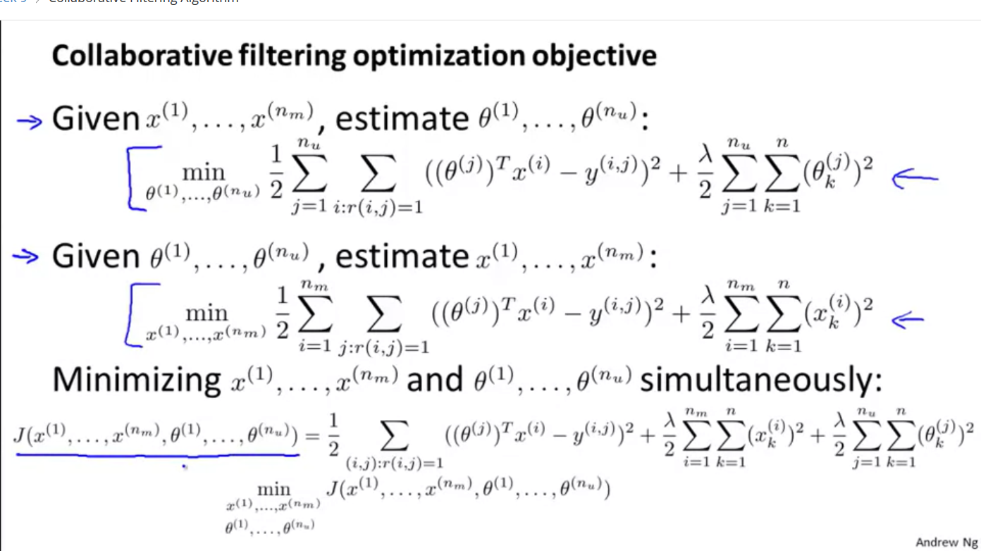

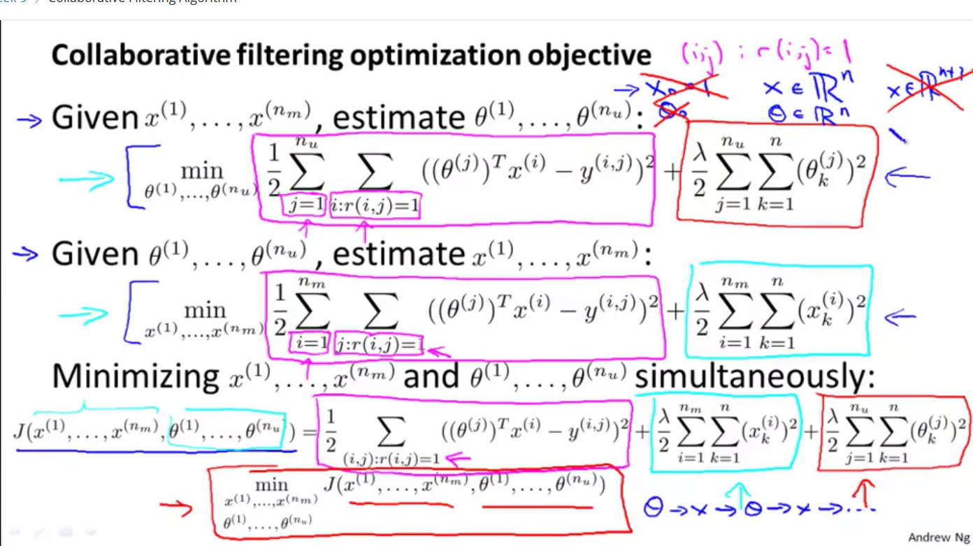

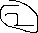

We have combined the 2 cost functions 1 and 2 to get the cost function for collaborative filtering.

*Conclusion:*

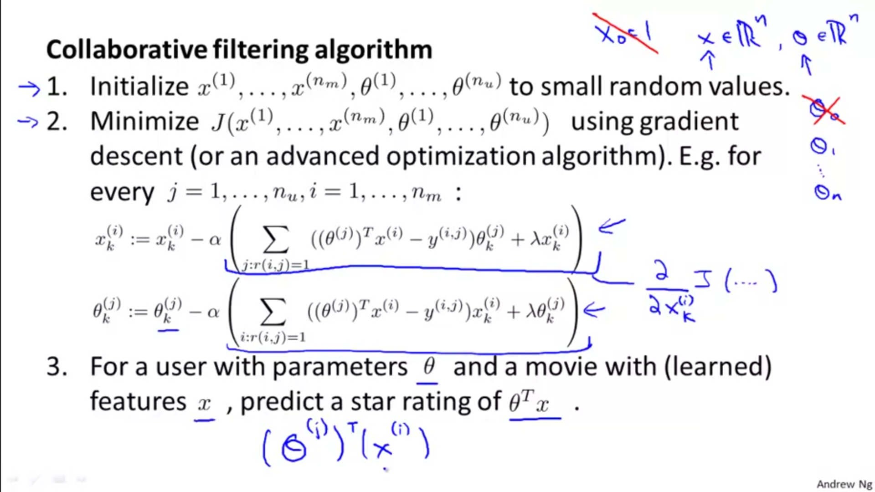

*Question:*

